Learning to Cut with Scissors ~ First Steps
Child development experts believe that children should begin to develop scissor skills
when they are 3 or 4 years old.
The child must first learn how to properly handle age-appropriate scissors. Teach him to always hold the scissors with his thumb toward the ceiling with his dominant hand. | 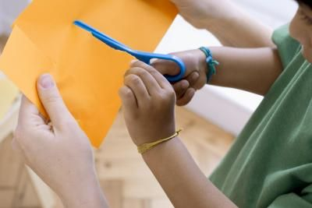
Practice cutting with a large (not too thick) piece of paper and children's safety scissors.  Don't try to direct where or how to cut too much; the goal is to experiment. | 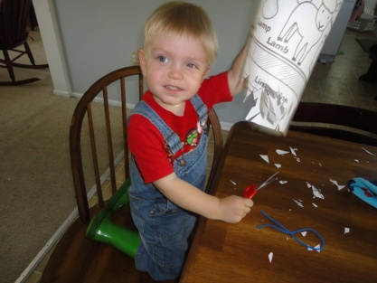
Practice cutting play dough with plastic (or regular) children's scissors. You can sometimes roll the dough into "snakes" for the child to cut. | 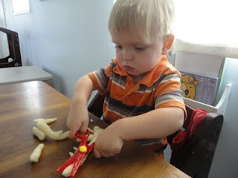
Magazine Cutting  Provide children with selected pages from a catalogue and safety scissors. Give them a purpose for cutting pictures. For instance, have them cut out pictures of objects that begin with a specific sound a letter makes, or items of a topic that is of interest to them. Have them glue the images onto a piece of paper. | 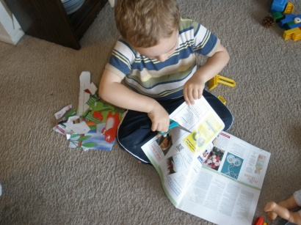
Grass Scene  Use a green piece of construction paper and have the child snip a fringe to create grass for a jungle or farm scene. You may also have them cut corners from other colors of paper and use those small cuttings to create scenes. | Fences  Use construction paper and have children cut on the long sides beginning from the bottom and moving along to the top. Use these pieces to build a fence on a collective mural or on their individual project.

Learning to Cut with Scissors

Tear pages out of School Supply catalogues that might interest children and place in a tub or other container.
Attach scissors with a tread to a tub.
Ask children what they would want to cut with questions such as:
- What is your favourite ...

- If you could choose ...

- What would you use to ...

- Can you find a picture that starts with the sound we talked about ...

Ask the children if they want to glue these items on a paper or would they prefer to keep them in an envelope that they can make.

