**We’re going on a sound hunt**

**We’re going on a sound hunt.**

**We’re going to find a noisy one.**

**What a beautiful day!**

**We’re not scared.**

|  |  |
| --- | --- |
|  | **[http://images.clipartpanda.com/firetruck-clipart-black-and-white-brigade-clipart-dTro7oaT9.gif](http://www.google.ca/url?sa=i&rct=j&q=&esrc=s&source=images&cd=&cad=rja&uact=8&ved=0ahUKEwjJ6NadwpjMAhVmtYMKHeomB84QjRwIBw&url=http://www.clipartpanda.com/categories/fire-truck-clipart-black-and-white&bvm=bv.119745492,d.amc&psig=AFQjCNGUu1Mrhm6v2Ot7GWGjrIkXVvJRpw&ust=1461080243720102)** |
|  | **[http://www.dltk-teach.com/books/brownbear/clips/sbird.gif](http://www.google.ca/url?sa=i&rct=j&q=&esrc=s&source=images&cd=&cad=rja&uact=8&ved=0ahUKEwiv3ejZwJjMAhVBsYMKHfQPApsQjRwIBw&url=http://www.dltk-kids.com/adopt/birds.htm&bvm=bv.119745492,d.amc&psig=AFQjCNEombguLNXyQPMRXlBvGA7_3kN4Og&ust=1461079823560534)** |
|  | **C:\Users\Helene Cleare\Pictures\1 Science\blue_car_clip_art_15789.jpg** |
|  | **[http://images.clipartpanda.com/fly-clipart-fly-gray.png](http://www.google.ca/url?sa=i&rct=j&q=&esrc=s&source=images&cd=&cad=rja&uact=8&ved=0ahUKEwiy78nDwZjMAhUkn4MKHZOxAWcQjRwIBw&url=http://www.clipartpanda.com/categories/fly-clip-art&bvm=bv.119745492,d.amc&psig=AFQjCNEv0qokOFf2Z_rEMw0CIl_J9jpqqQ&ust=1461080033794779)** |
|  |  |

**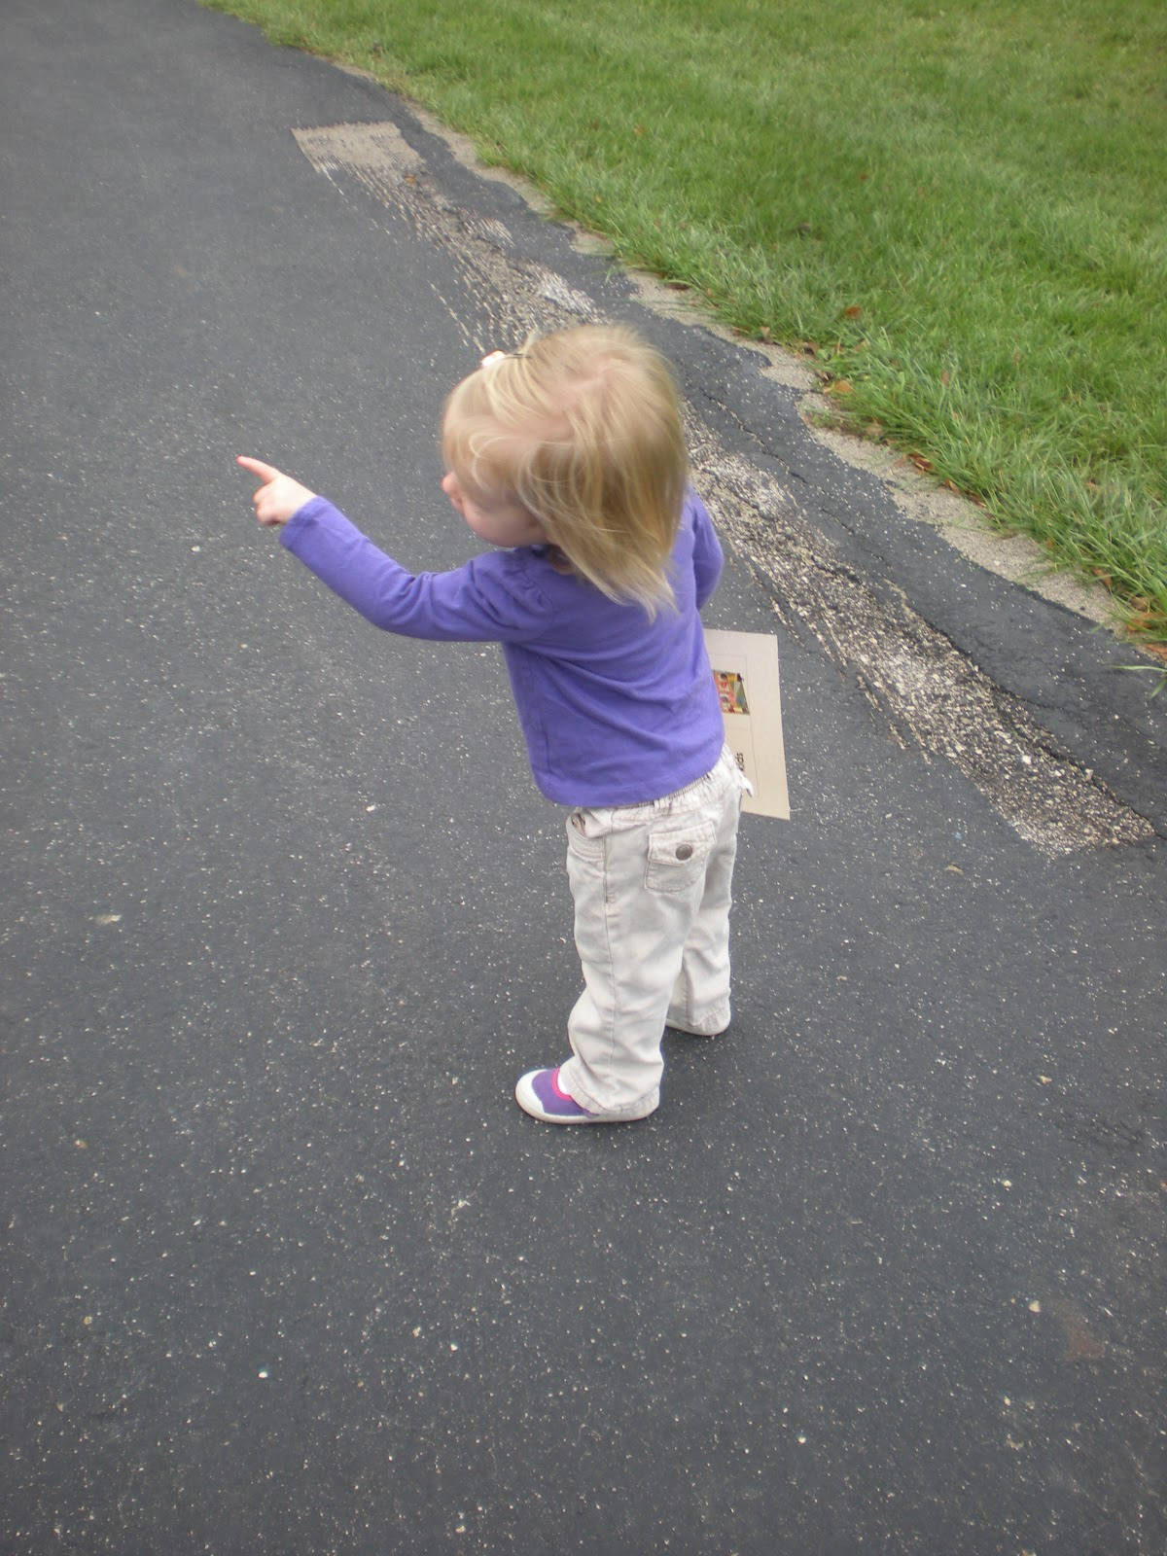**

**We’re Going on an Insect Hunt**

**We’re going on an insect hunt**

**We’re going to find a small one.**

**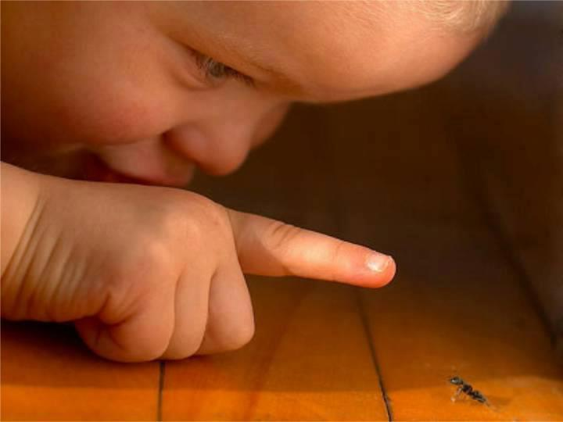**

**What a beautiful day!**

**We’re not scared.**

|  |  |
| --- | --- |
| **insect.jpg** | **insect2.jpg** |
| **Insect3.jpg** | **insect1.jpg** |