[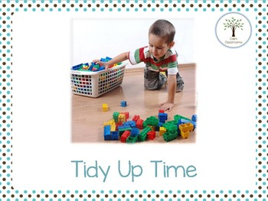](https://www.google.com/url?sa=i&rct=j&q=&esrc=s&source=images&cd=&cad=rja&uact=8&ved=2ahUKEwjxtN2avqfeAhWum-AKHcTAAhMQjRx6BAgBEAU&url=https://www.teacherspayteachers.com/Product/Tidy-Up-TIme-A-Social-Script-for-Reluctant-Tidiers-3017363&psig=AOvVaw1IE1Jpry73OWjpHQMmEIvv&ust=1540759333849904)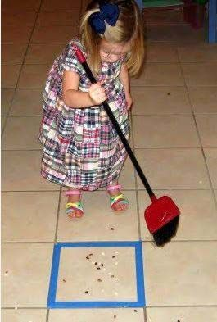 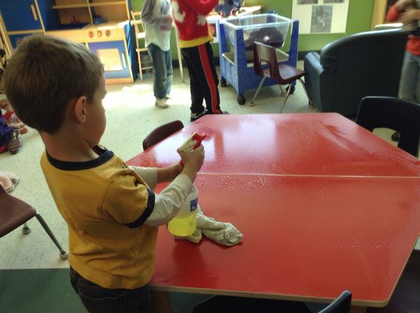

**C’est le temps de tout ranger.**

[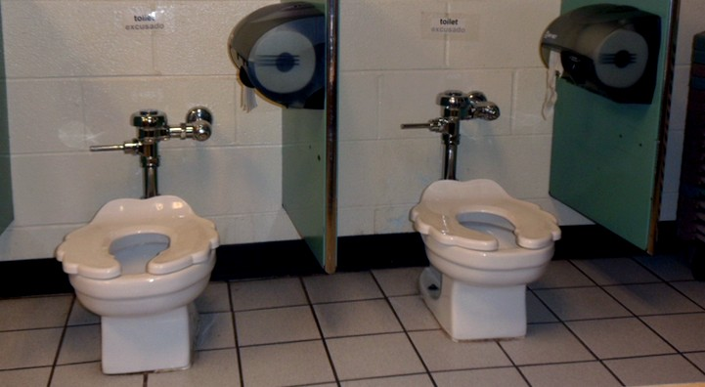](https://www.google.com/url?sa=i&rct=j&q=&esrc=s&source=images&cd=&cad=rja&uact=8&ved=2ahUKEwiBsovgyqfeAhWDTN8KHQi_CK8QjRx6BAgBEAU&url=https://articles.extension.org/pages/63292/creating-safe-and-appropriate-diapering-toileting-and-hand-washing-areas-in-child-care&psig=AOvVaw2FSPF3Rlusv7Sk-v0p_ilt&ust=1540762747747585) [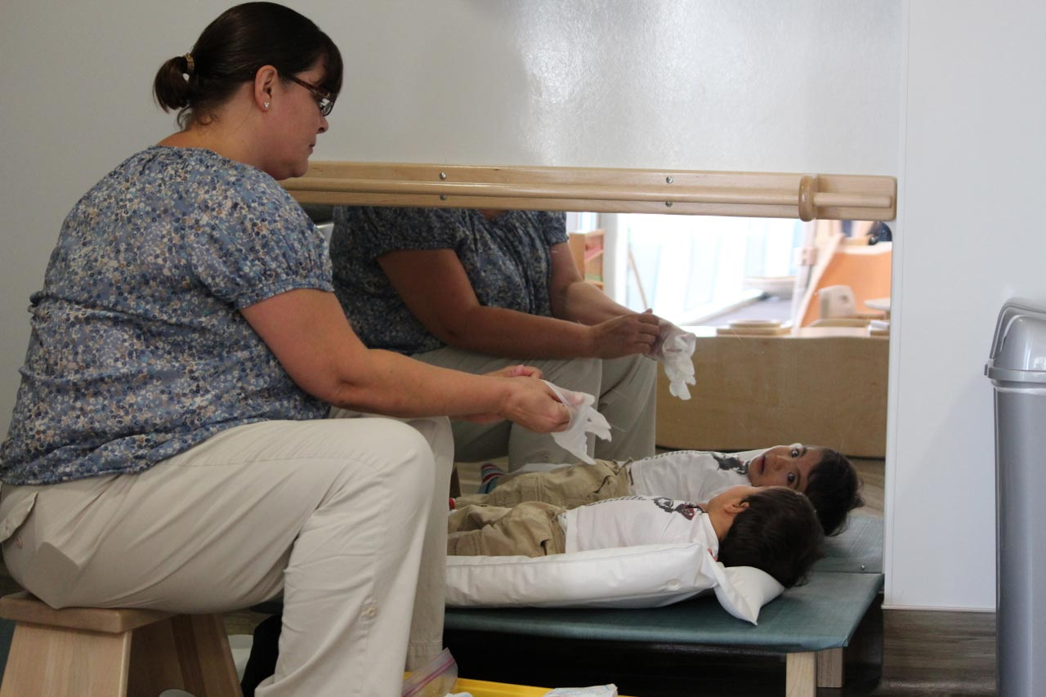](https://www.google.com/url?sa=i&rct=j&q=&esrc=s&source=images&cd=&cad=rja&uact=8&ved=2ahUKEwi4z-eQy6feAhXymeAKHU_XDEsQjRx6BAgBEAU&url=https://www.leportschools.com/blog/toilet-learning-a-montessori-perspective/&psig=AOvVaw2wF6UIZfrw0sLT28Z3m1VB&ust=1540762860597186)

**C’est le temps de la toilette.**



**C’est le temps de manger.**

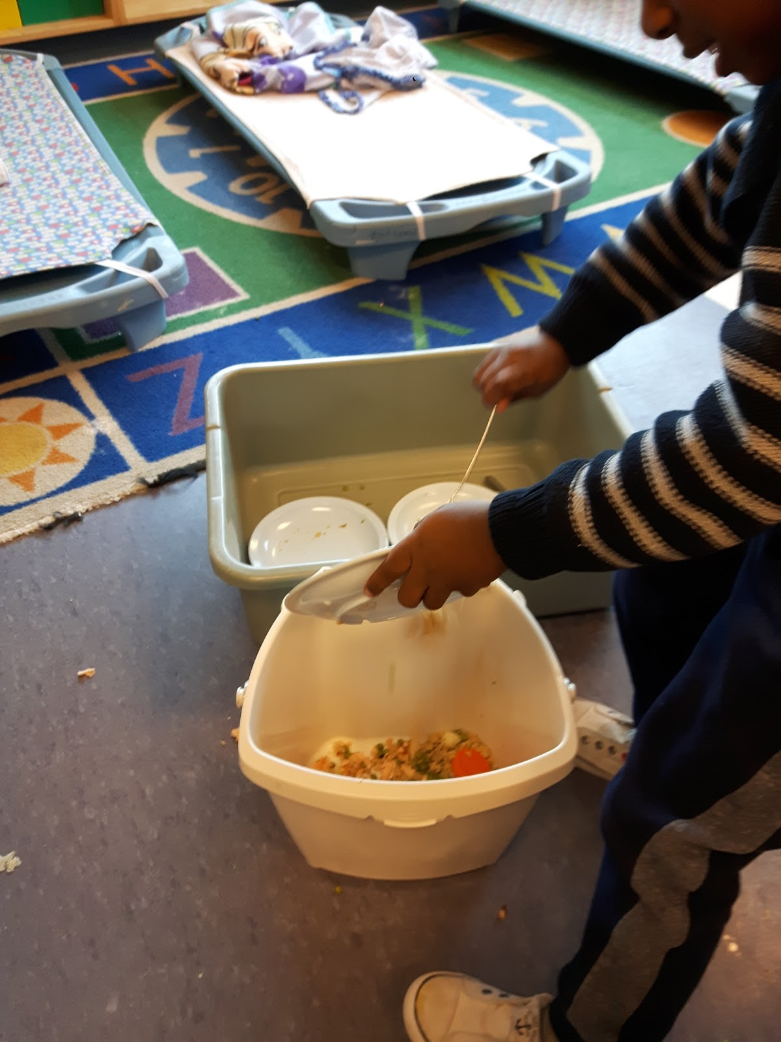

**C’est le temps de nettoyer et ranger son assiette.**

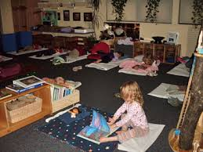

**C’est le temps de s’installer pour la sieste.**

[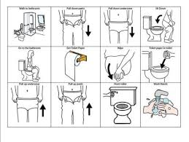](https://www.google.com/imgres?imgurl=https://corticalchauvinism.files.wordpress.com/2018/03/visual-guide.jpg?w=470&imgrefurl=https://corticalchauvinism.com/2018/04/02/toilet-training-and-autism/&docid=1MJEac0WVZIJLM&tbnid=5VO3bDCsmkn52M:&vet=10ahUKEwjhxqDZuqfeAhXRTd8KHd1QDO8QMwhiKBUwFQ..i&w=470&h=354&bih=521&biw=1093&q=washroom%20routine%20chart&ved=0ahUKEwjhxqDZuqfeAhXRTd8KHd1QDO8QMwhiKBUwFQ&iact=mrc&uact=8)