TDSB In-Service

Parenting and Family Literacy Centre Professional Learning Meeting

Art in a Parenting and Family Literacy Centre

x
Goal: To demonstrate developmentally appropriate art in a PFLC

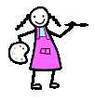

AGENDA

Welcome

Art Activities

Group Discussion

Every Child is an Artist.
The problem is how to remain an artist when he or she grows up

Pablo Picasso

Format: - Time allocated – 2 hours

1. Set up 4 demonstration tables with art activities for staff to experience.
2. Staff rotate from table to table to experiment with the art activities. (45 mins., approx 10 mins. per activity.)
3. Small group discussion with the following guiding questions:

1. Which activity did you like the best and why?

2. Anything you would add/ change and why?

3. What do you think children might learn from this activity?

4. How do you see your role as a parent worker?

5 .How do you see as the parents role?

6. Do you anticipate any challenges in doing the activity in your PFLC?

Feedback discussion covered:

1. The Learning Environment: - time, space, resources
  - extend the children’s experience
  - be plentiful
  - accessible
  - age appropriate
  - be of high quality
  - addition of organic materials
  - time to revisit an activity
  - storage space

2. Learning Outcomes: Kindergarten program/ ELECT

ELECT Document: Domains and Skills to Consider

(Toddlers 14 months- 3 years)
- Empathy
- Sense of self
- Autonomy
- Identity information
- Receptive language
- Expressive language
- Spatial exploration
- Spatial observation
- Temporal
- Symbolic thought
- Memory
- Sorting
- Sensory Exploration
- Discrimination
Discussion included:

- No right or wrong way to experience art
- Include science in art
- Builds self esteem
- Oral language – incorporate books where appropriate e.g. Mouse Paint
- Scaffolding materials e.g. paint , then add pasting

3. The Role of the Adult - Parent, Parent Worker:

The Parent Worker sets the stage, organizes and presents an activity that encourages exploration and inquiry and then observes and documents the process. Taking the cue from the child the Parent Worker role models and makes the connection for the parents between the art activity and the learning that is taking place and the skills that are being developed.

Key Messages:

    - This should be a positive experience, be sensitive to learning styles, temperaments and multi –age grouping
    - Art activities should be developmentally appropriate
    - The process is valued over the product
    - Strict time limits are removed
    - Self expression is encouraged and valued
    - Children have opportunities to share ideas with each other the parent and PW – model conversations
    - Observe, wonder, hypothesize- “I wonder what would happen if?”
    - Risk taking is encouraged
    - Competition and external rewards(praise junkies) are minimized
    - Model parent engagement vs parental interference

4. Anticipated Challenges:

- Pressure to have a finished product
- Parents directing the activity as opposed to observing and playful interaction
- Objections to messy activities
- Multi age grouping
- Time constraints/inconsistent attendance

Activities:

1. Box and Wood gluing

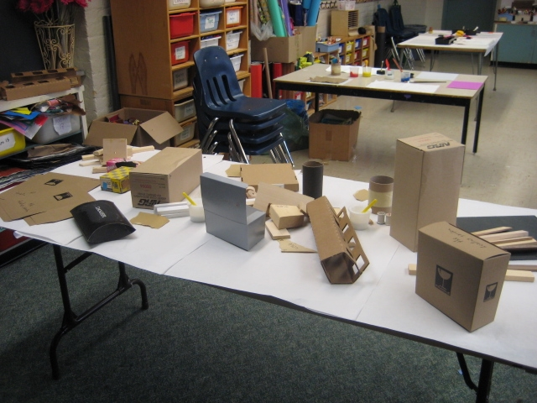
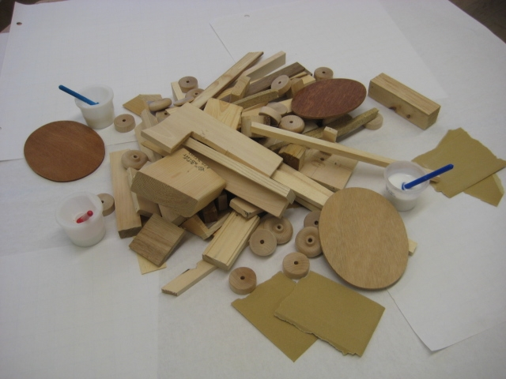

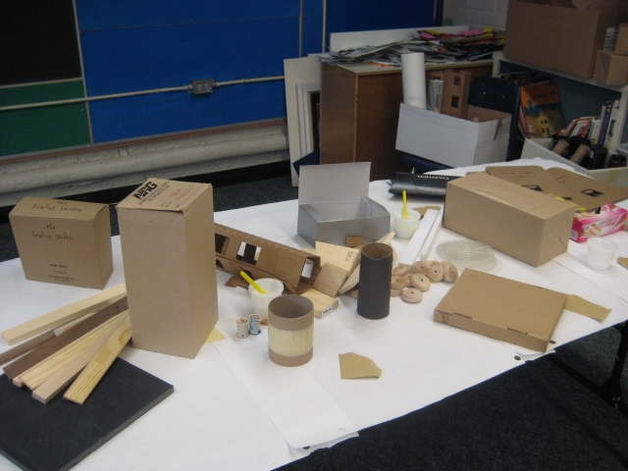

Materials: Variety of different shapes and sized boxes.
Collection of small assorted wood pieces
Glue

2. A Variety of Painting Activities

Materials:

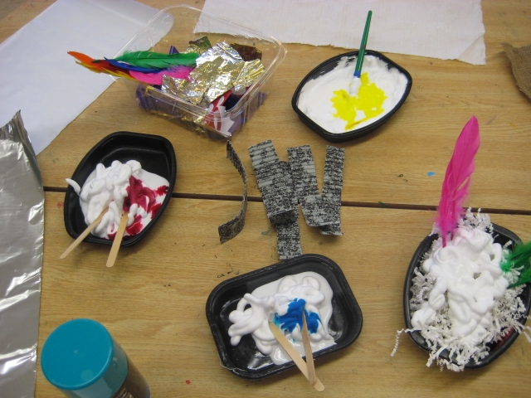
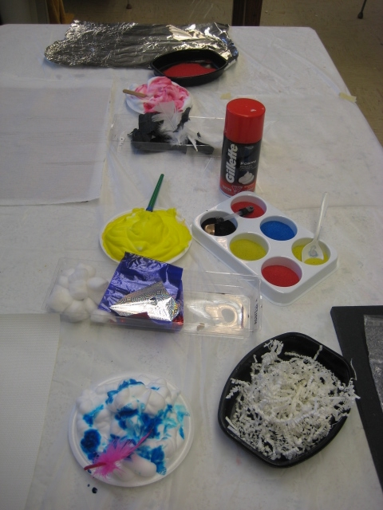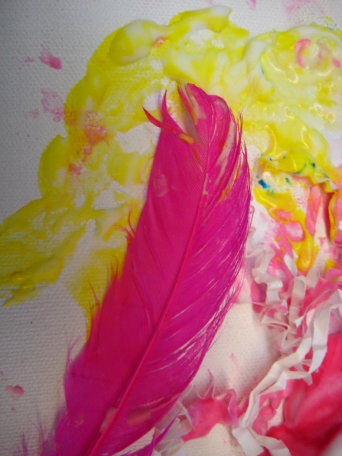

Assorted painting utensils such as brushes, feathers, kitchen utensils, potato masher, scrappers, rollers, lego, sponges

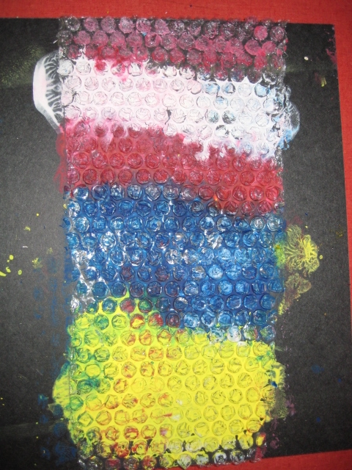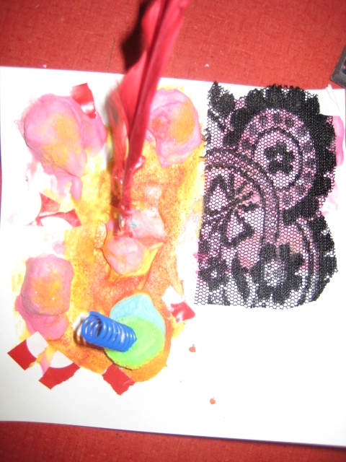

Assorted papers such as wax paper, tin foil, shiny paper, wallpaper ,fabric with different textures, burlap.

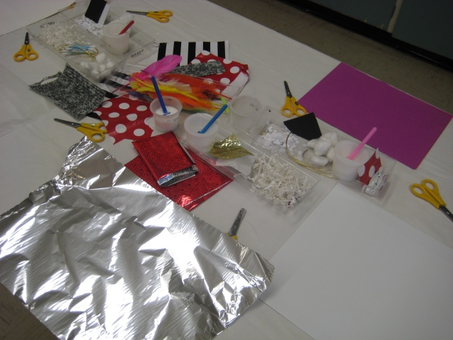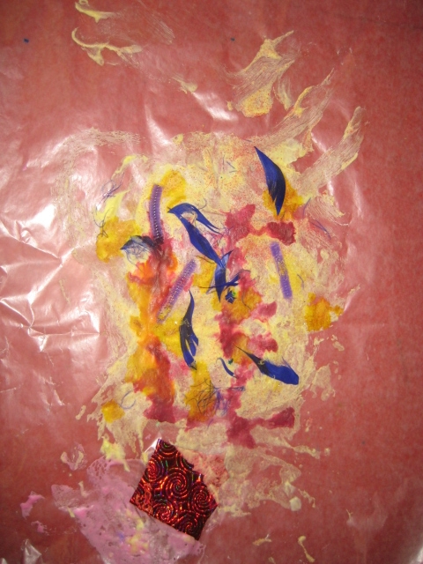

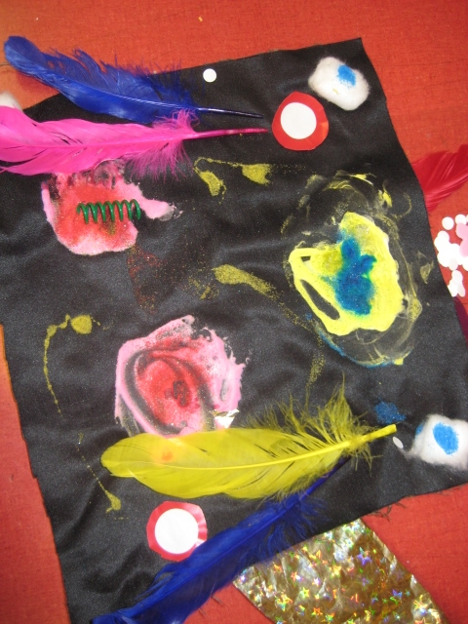
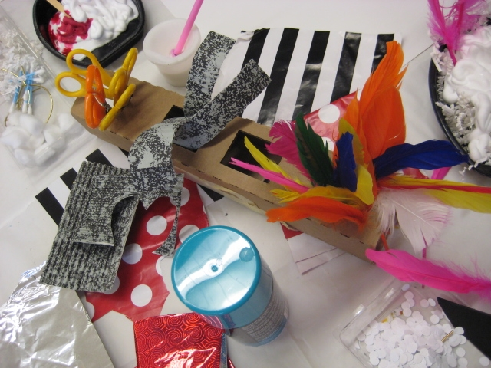

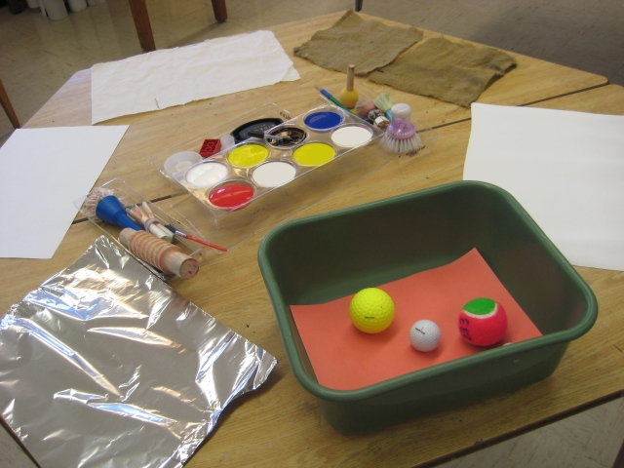
Assorted balls such as golf balls, ping pong balls, other objects that roll e.g. pine cones
9 x 11 paper white paper
Primary coloured paints, red, yellow, blue
Cardboard or plastic containers with a 1” - 2” lip. (Can use a shoebox)
Lay the paper flat in the box. Spoon coloured paint, roll ball on paper to make patterns.

3. Activity: Sensory - Play Dough activities

5 different play dough recipes, coffee flavoured, kool-aid, plain, herbs,
orange jello with added orange peel.
A collection of different play dough items such as garlic press, lego, potato masher, insects, dinosaurs, shells, fish, feathers, popsicle sticks, spaghetti press

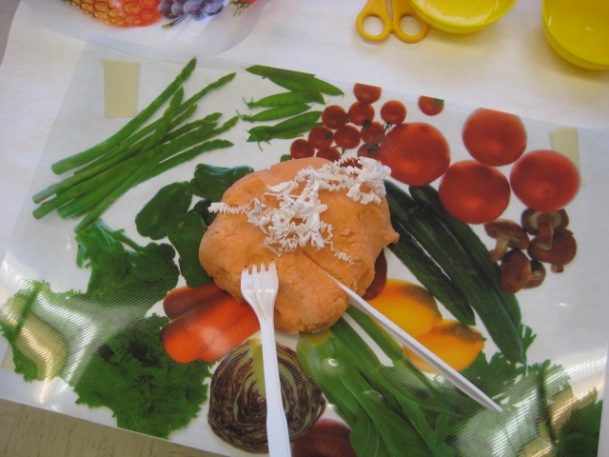
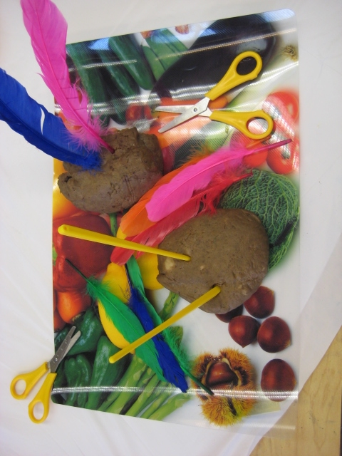
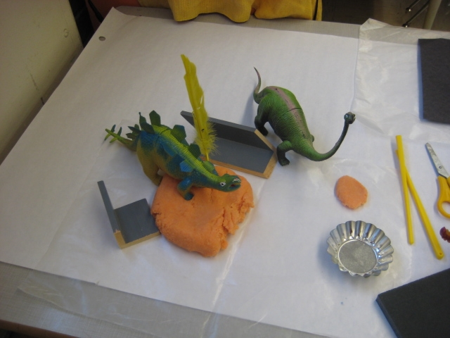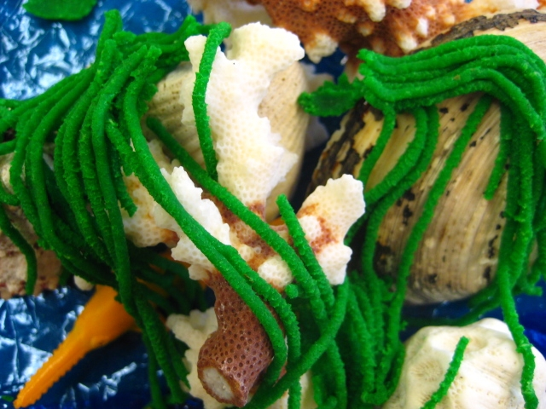

Different papers to set up display such as blue cellophane for fish display, place mats
for kitchen items, hard card board covered in sand paper for dinosaurs

4.Activity: Sensory Collage

Glue
Shaving cream
Assorted paper or cardboard
Assorted materials for pasting such as feathers, sequins, cotton balls,
tissue, foil, cellophane paper, different textured materials, wool, string,
pipe cleaners, straws, ribbon.
Food colour, red, yellow, blue
Plastic containers, bowls for mixing,
Wooden spoons for mixing
Paint brushes, Q’tips

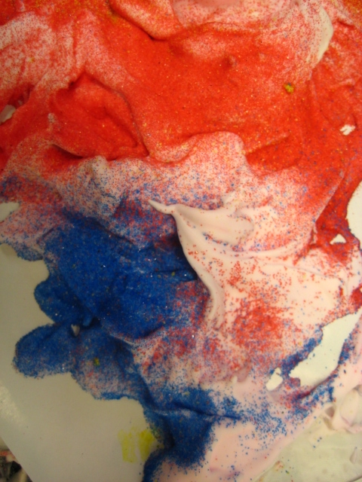
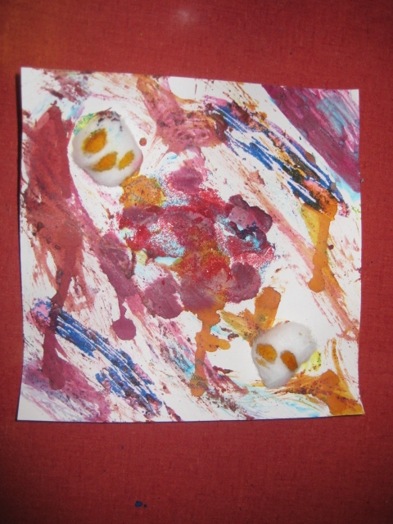

Playdough Recipes

No-cook Playdough
Ingredients:  - 2 cups flour  - ½ cup salt  - 1 Tbs. cooking oil  - 2 cups boiled water  - 2 Tbs. cream of tartar  - food colouring | Method:  Mix flour, salt, oil. Add food coloring to boiled water. Gradually add water to flour mixture. Knead. Store in a plastic bag in the refrigerator

Playdough (cooked)
Ingredients:  - 2 cups water  - 2 cups flour  - 1 cup salt  - 2 Tbs. cooking oil  - 4 Tsp. cream of tartar  - food colouring | Method:  Combine ingredients. Cook in electric skillets, stirring constantly, until most of the moisture is absorbed. If you like you can knead in glitter for sparkly playdough when the dough cools. Store in a covered container.  (does not need to be refrigerated)

Oatmeal Playdough
Ingredients:  - 1 part flour  - 1 part water  - 2 parts oatmeal | Method:  Mix all ingredients until smooth. Knead.  (non-edible)

Kool-Aid Playdough
Ingredients:  - 1/2 cup salt  - 2 cups boiled water  - 2 cups flour  - 2 Kool-Aid pkg. | Method:  Mix dry ingredients together. Add boiling water. Knead until smooth. Keeps for two months or longer if stored right.

Salt Playdough
Ingredients:  - 1 cup salt  - 1 cup water  - 1/2 cup flour  - food colouring | Method:  Mix ingredients and cook over low/medium heat. Remove from heat when thick and rubbery. As mixture cools, knead in enough flour to make a workable dough.

Coffee Playdough Playdough
Ingredients:  - 4 cups flour  - 1 cup salt  - ¼ cup instant coffee  - 1 ½ cup warm water | Method:  Dissolve the coffee in the warm water. In another bowl, mix the flour and the salt. Make a well and add 1 cup of the coffee water into it. Mix with a fork or with your hands until smoother. Add more coffee water as needed: dough should be smooth not sticky or crumbling. You can also bake in oven for 1 hour at 300 degrees or until hard.

Cloud Playdough
Ingredients:  - 6 cups flour  - 1½ vegetable oil  - 1 cup water  - food colouring | Method:  Add a few drops of food colouring to water. Combine water, oil and flour in a large bowl. Knead well until the dough is soft and stretchy. It’s very greasy

Fruit Playdough
Ingredients:  - 2 cups boiling water  - 2 cups flour  - 1 cup salt  - 2 Tbs. cooking oil  - 4 Tbs. cream of tartar  - 3 oz package sugar-free fruit  - flavoured gelatin | Method:  Mix dry ingredients in pan. Add the water and oil. Stir over medium heat until mixture forms a ball. Pour onto a sheet of wax paper and knead well.

Salt Glitter
Ingredients:  - ½ cup salt  - Food colouring | Method:  Add food colour to salt adjusting to desired colour. Cook in the microwave 1-2 minutes. To keep soft store in air-tight container.

Jell-O Finger Paint
Ingredients:  - Any flavour gelatine  - Boiling water | Method:  Use water and add to Jell-O until finger paint consistency. Paint away and it smells great

Kool-Aid Finger Paint
Ingredients:  - 2 cups flour  - 2 packages of unsweetened Kool-aid  - ½ cup salt  - 3 cups boiling water  - 3 Tbs. oil | Method:  Mix all ingredients together until finger paint consistency.

Cornstarch Clay
Ingredients:  - 1 cups flour  - 2 cup salt  - 1 1/3 cups cold water | Method:  Put salt and 2/3 cup water in pan and bring to a boil. Mix cornstarch with 2/3 cup water and mix well. Blend 2 mixtures together and knead into clay. The dough has to be heated as it is combined to set. Makes a about 3 cups. This clay can be air dried and then painted. Store unused clay in airtight container in the fridge.

Cooked Clay Dough
Ingredients:  - 1 cup flour  - ½ cup cornstarch  - 4 cups water  - 1 cup salt  - 3 or 4 pounds flour  - food colouring | Method:  Stir slowly and be patient with this recipe. Blend the flour and cornstarch with cold water. Add salt to the water and boil. Pour the boiling salt and water solution into the flour and cornstarch paste and cook over hot water until clear. Add the flour and colouring to the cooked solution and knead. Keeps 2/3 weeks in container.

Shaving Cream Paint
- shaving cream  - 2 Tbs. – ½ cup glue  - food colouring | Fill a small bowl with shaving cream. Add glue and food colouring. If you use 2 Tbs. of glue use as paint or for gluing light materials. If you add more glue the consistency is thicker and you can be more creative.

