**On s’amuse à découper !**

     

**[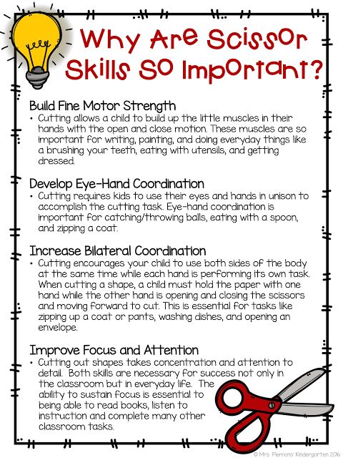](http://theelementaryentourage.blogspot.com/2016/11/integrating-arts-in-kindergarten.html)**

**[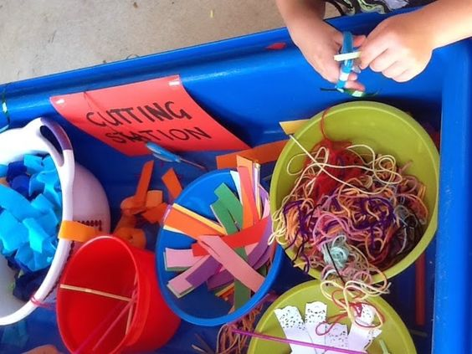](http://niccolaontuesday.blogspot.com.au/2014/10/cutting-station.html)** 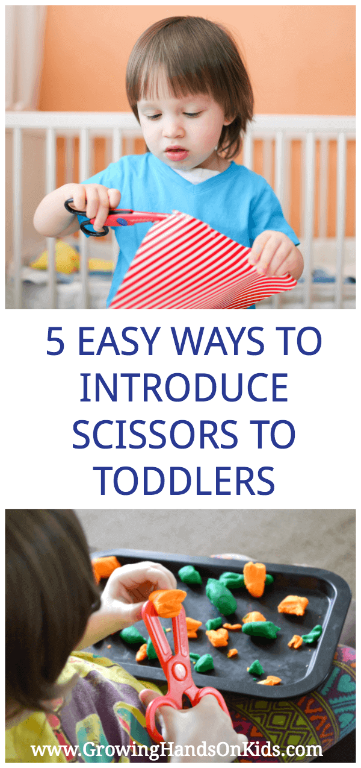  

**[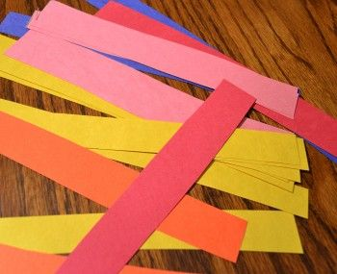](http://creativeconnectionsforkids.com/2011/01/cutting-up-fine-motor-activities-to-help-develop-scissor-skills/)** **[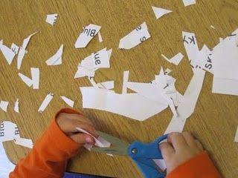](http://www.teachpreschool.org/2009/11/preschoolers-need-opportunties-to-develop-their-cutting-skills/)** 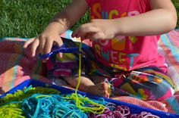 [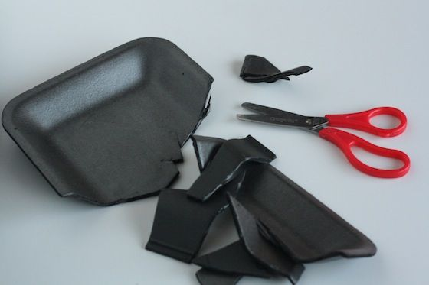](http://happyhooligans.ca/2013/04/15/scissor-exercises-for-children/)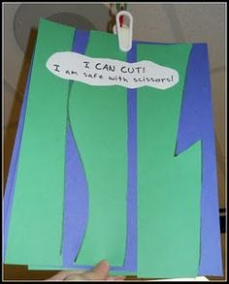 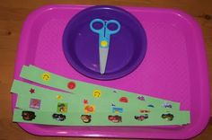 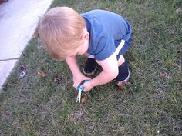 [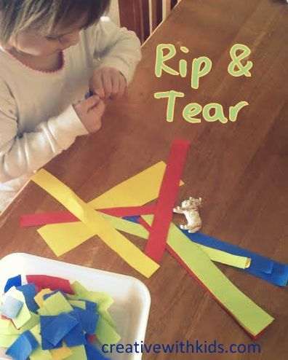](http://toyspark.blogspot.com/2013/08/5-quiet-activities-for-toddlers-to-do.html)

**[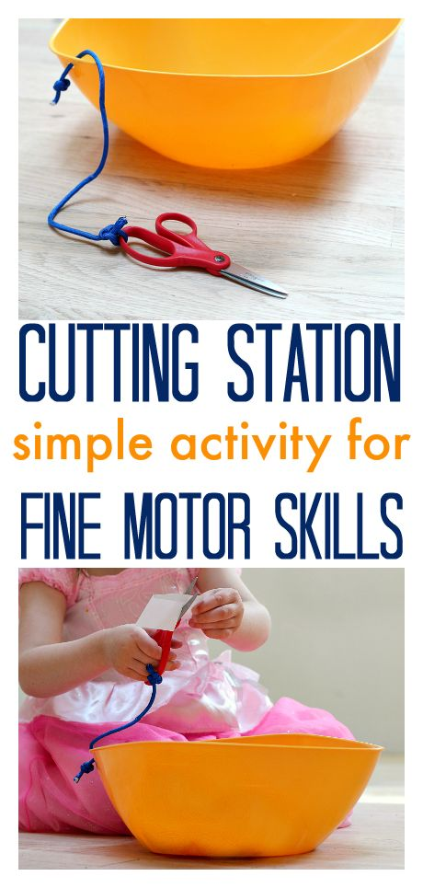](http://www.notimeforflashcards.com/2014/05/fine-motor-skills-diy-cutting-station.html)** **Autres idées pour développer les habiletés pour le ciseau. [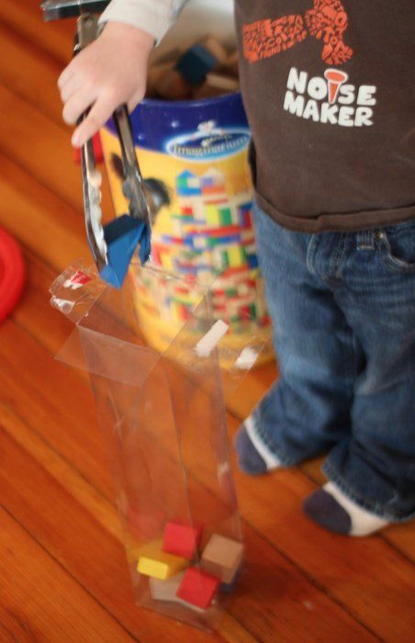](http://handsonaswegrow.com/block-fine-motor-toddler-activity/)**

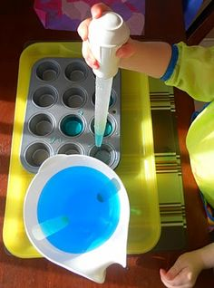 **[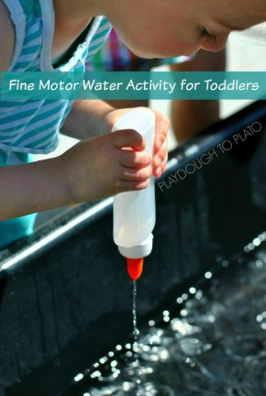](http://www.playdoughtoplato.com/fine-motor-water-activity-for-toddlers/) 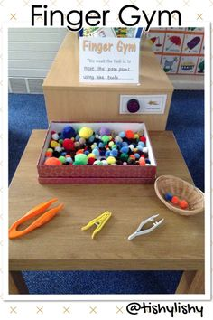 [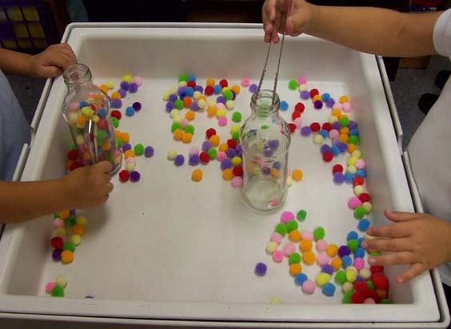](http://prekinders.com/sensory-table/)**