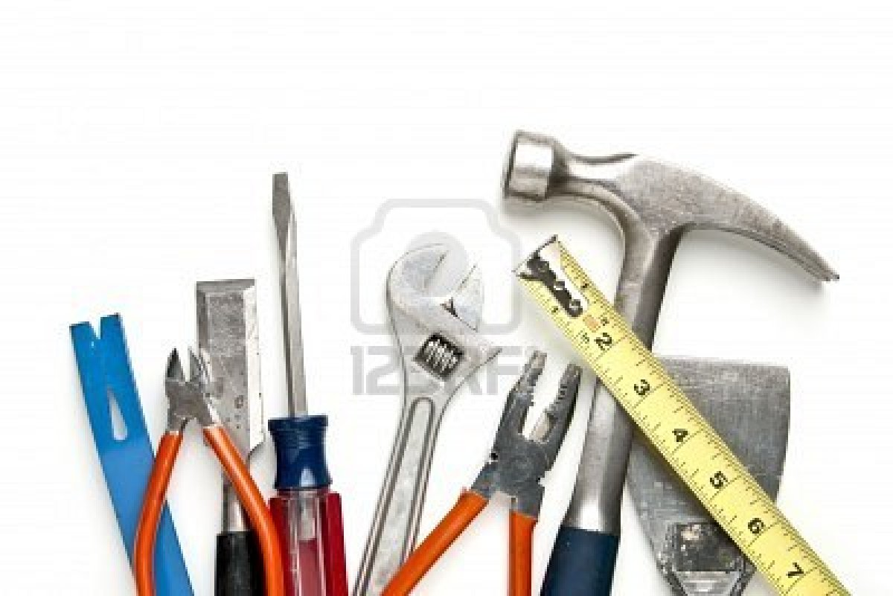

Outils de construction

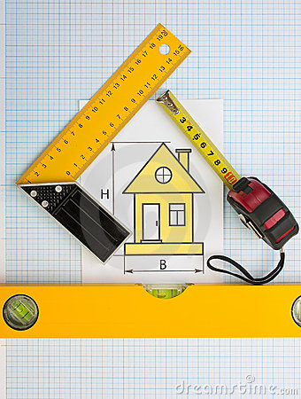



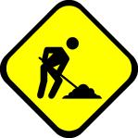

**Construction**



Construction

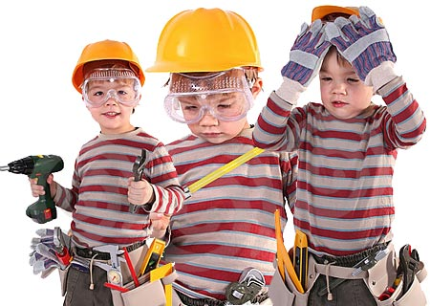

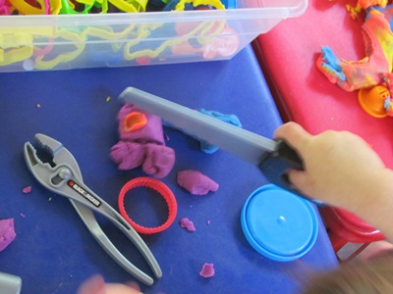

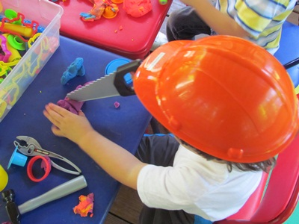

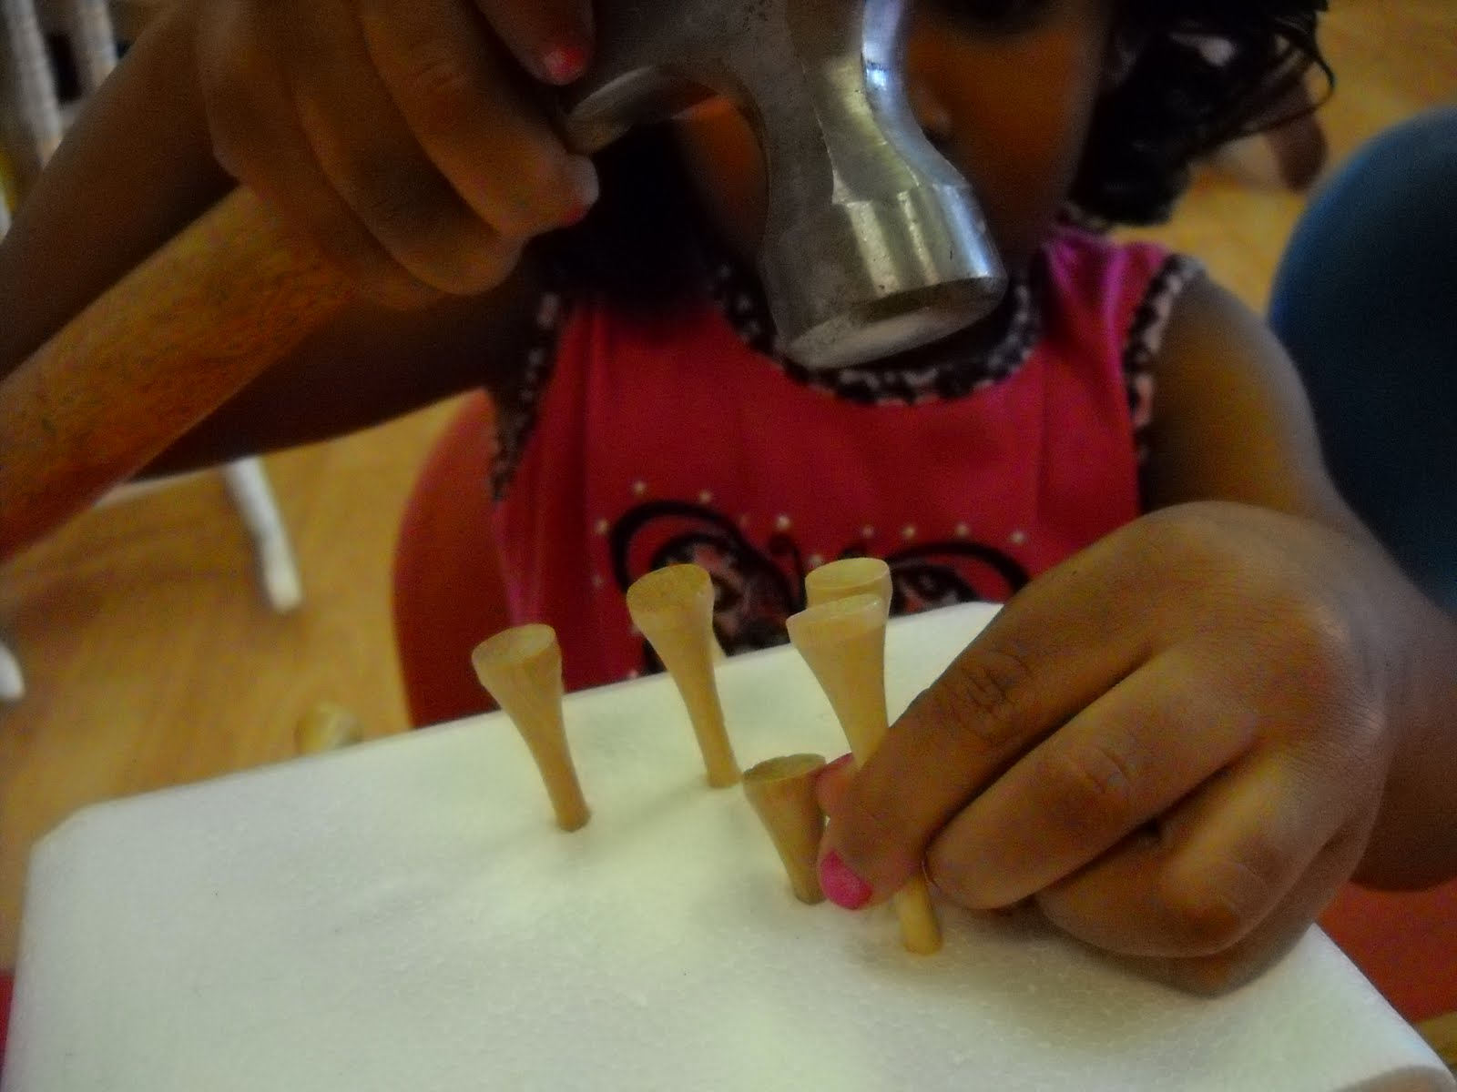

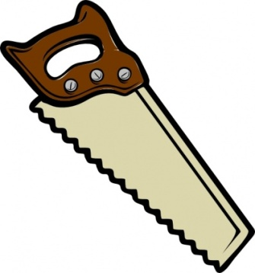 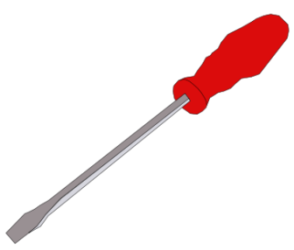

Related searches:[**clip art hammer**](http://www.google.ca/search?hl=en&qscrl=1&nord=1&rlz=1T4TSCA_enCA437CA433&biw=1366&bih=554&tbm=isch&q=clip+art+hammer&revid=1883799297&sa=X&ei=kmt-T_uXNojPgAfU6MH7DQ&ved=0CDwQgxY)

[](http://www.google.ca/imgres?q=clip+art+tools&hl=en&sa=X&qscrl=1&nord=1&rlz=1T4TSCA_enCA437CA433&biw=1366&bih=554&tbm=isch&prmd=imvns&imgrefurl=http://clipart-for-free.blogspot.com/2010/05/hammer-clipart.html&tbnid=d0lT_0hPSDMlyM&docid=0xCLVRCKymaDqM&ved=0CD8QhRYoAA&ei=kmt-T_uXNojPgAfU6MH7DQ)[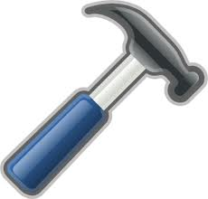](http://www.google.ca/imgres?q=clip+art+tools&hl=en&sa=X&qscrl=1&nord=1&rlz=1T4TSCA_enCA437CA433&biw=1366&bih=554&tbm=isch&prmd=imvns&imgrefurl=http://clipart-for-free.blogspot.com/2010/05/hammer-clipart.html&tbnid=9SXmt6j5TcH3qM&docid=0xCLVRCKymaDqM&ved=0CEAQhRYoAQ&ei=kmt-T_uXNojPgAfU6MH7DQ)[](http://www.google.ca/imgres?q=clip+art+tools&hl=en&sa=X&qscrl=1&nord=1&rlz=1T4TSCA_enCA437CA433&biw=1366&bih=554&tbm=isch&prmd=imvns&imgrefurl=http://www.clipartheaven.com/show/clipart/hands/hammer-gif.html&tbnid=DXsv_nAecZAiCM&docid=DJp_KqFJ3OgPEM&ved=0CEEQhRYoAg&ei=kmt-T_uXNojPgAfU6MH7DQ)

