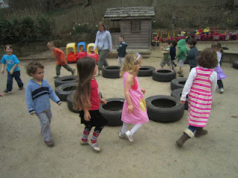

We tried a new spin on musical chairs using the tires we had on our playground. We put the tires in a circle. While we set up the music, the children enjoyed guessing what we were going to do with the tires in this arrangement.
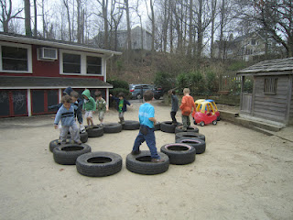
Then we explained the game. Each time the music stopped they needed to sit or get some part of their bodies on a tire. Each time the music stopped we would be taking a tire away-not a child! The children were never out. However, each time the seating became more limited and the negotiating for a place became trickier.
