**Quel temps fait-il ? Mois ___________**

|  |  |  |  |  |  |  |  |  |  |  |  |
| --- | --- | --- | --- | --- | --- | --- | --- | --- | --- | --- | --- |
|  |  |  |  |  |  |  |  |  |  |  |  |

|  |  |  |  |  |  |  |  |  |  |  |  |
| --- | --- | --- | --- | --- | --- | --- | --- | --- | --- | --- | --- |
|  |  |  |  |  |  |  |  |  |  |  |  |

|  |  |  |  |  |  |  |  |  |  |  |  |
| --- | --- | --- | --- | --- | --- | --- | --- | --- | --- | --- | --- |
|  |  |  |  |  |  |  |  |  |  |  |  |

|  |  |  |  |  |  |  |  |  |  |  |  |
| --- | --- | --- | --- | --- | --- | --- | --- | --- | --- | --- | --- |
|  |  |  |  |  |  |  |  |  |  |  |  |

|  |  |  |  |  |  |  |  |  |  |  |  |
| --- | --- | --- | --- | --- | --- | --- | --- | --- | --- | --- | --- |
|  |  |  |  |  |  |  |  |  |  |  |  |

**Quel temps fait-il ?**

|  |  |  |  |  |  |  |  |  |  |  |  |
| --- | --- | --- | --- | --- | --- | --- | --- | --- | --- | --- | --- |
|  |  |  |  |  |  |  |  |  |  |  |  |

|  |  |  |  |  |  |  |  |  |  |  |  |
| --- | --- | --- | --- | --- | --- | --- | --- | --- | --- | --- | --- |
|  |  |  |  |  |  |  |  |  |  |  |  |

|  |  |  |  |  |  |  |  |  |  |  |  |
| --- | --- | --- | --- | --- | --- | --- | --- | --- | --- | --- | --- |
|  |  |  |  |  |  |  |  |  |  |  |  |

|  |  |  |  |  |  |  |  |  |  |  |  |
| --- | --- | --- | --- | --- | --- | --- | --- | --- | --- | --- | --- |
|  |  |  |  |  |  |  |  |  |  |  |  |

|  |  |  |  |  |  |  |  |  |  |
| --- | --- | --- | --- | --- | --- | --- | --- | --- | --- |
|  |  |  |  |  |  |  |  |  |  |

**What is the weather? Month ___________**

|  |  |  |  |  |  |  |  |  |  |  |  |
| --- | --- | --- | --- | --- | --- | --- | --- | --- | --- | --- | --- |
|  |  |  |  |  |  |  |  |  |  |  |  |

|  |  |  |  |  |  |  |  |  |  |  |  |
| --- | --- | --- | --- | --- | --- | --- | --- | --- | --- | --- | --- |
|  |  |  |  |  |  |  |  |  |  |  |  |

|  |  |  |  |  |  |  |  |  |  |  |  |
| --- | --- | --- | --- | --- | --- | --- | --- | --- | --- | --- | --- |
|  |  |  |  |  |  |  |  |  |  |  |  |

|  |  |  |  |  |  |  |  |  |  |  |  |
| --- | --- | --- | --- | --- | --- | --- | --- | --- | --- | --- | --- |
|  |  |  |  |  |  |  |  |  |  |  |  |

|  |  |  |  |  |  |  |  |  |  |  |  |
| --- | --- | --- | --- | --- | --- | --- | --- | --- | --- | --- | --- |
|  |  |  |  |  |  |  |  |  |  |  |  |

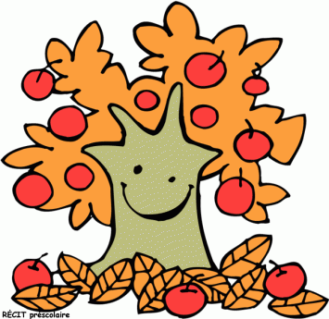

**Automne**

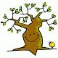

**Printemps**

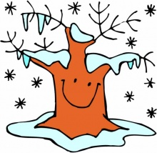

**Hiver**

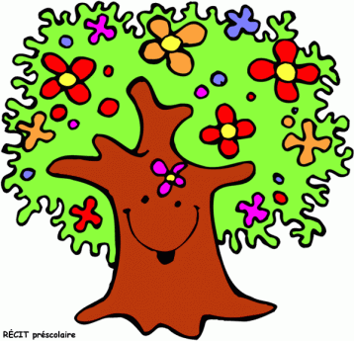

**Été**