Sink the Ship

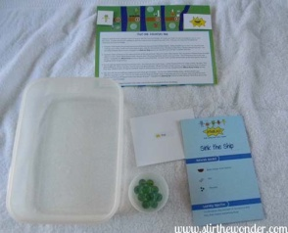
The first experiment we did was called “Sink the Ship”. The object of this experiment was to test the buoyancy of a square of tin foil and marbles.
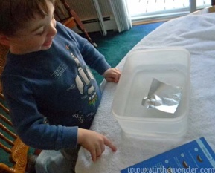
This experiment has two parts to it. First we tested a flat square of tin foil by placing it in the water to see if it would float or sink. Then we added one marble at a time to the square to see how many marbles the foil could hold before sinking.
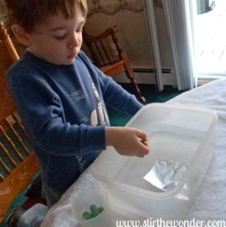
Caden took this experiment very seriously and carefully added the marbles one at a time. We found that the small square of tin foil could hold three marbles without sinking and sank with the fourth marble.
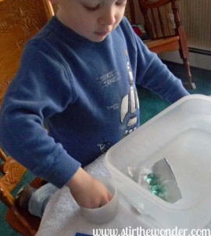
Next the instructions say to “make the foil into a boat”. I had a hard time folding the small piece of foil into a boat. Partly because I couldn’t remember how to fold a boat and it took me a few tries weakening the foil and partly because the foil was so small.
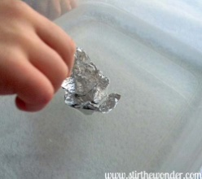
My sad foil boat wouldn’t float. So we got a big sheet of heavy-duty foil and made a bigger boat to do the second half of the experiment with.
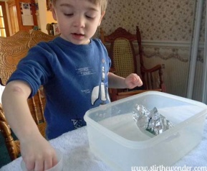
With our new and improved foil boat we tested to see how many marbles it would hold before sinking. At first Caden put one marble at a time into the foil boat.
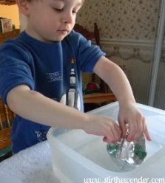
But then he wanted to speed things up a bit, so he took the boat out of the water and placed it on the table so he could dump the rest of the marbles from the cup into the boat.
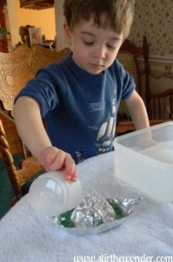
Then he placed the boat back in the container of water to see if it would
float or sink.
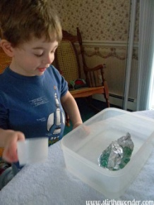
To our surprise, the boat floated with all the marbles in it! So Caden decided to further test the boat. He added some water to the boat to see how much the boat could handle before it sank!
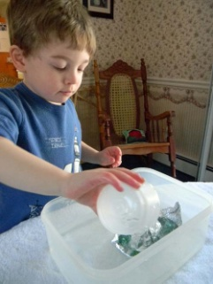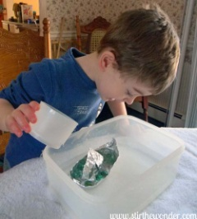
It didn’t take much water to sink the ship!

